Grade 7 Accelerated · Unit 6 · Thread B · Day 1  Angle Pairs: Supplementary, Complementary, Vertical, Adjacent  Independent Set 6.T1 | Name______________________  Date______________________  Period____________________

Six questions, on your own, in silence. Show the step that does the work.
1. What is the complement of 61°?

2. What is the supplement of 76°?

3. Two lines cross, and one of the four angles is 58°. Find the other three.

4. A linear pair measures 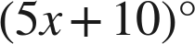 and 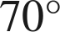. Find x and the first angle.

5. Vertical angles measure 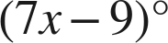 and 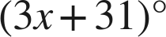. Find the measure of each angle.

6.  and  share the side QR and together make a straight line, and 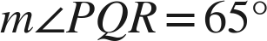. Name the pair and find 

